How to Fix Printers in Longmont
  - By John Oliver

Contents
Pre-requisites 3
Stopping the Spooler 4
Deleting the Files 5
Restarting the Spooler 6

Pre-requisites
- Administrative access to Grant.

Stopping the Spooler
- Login to the Grant server as the administrator.
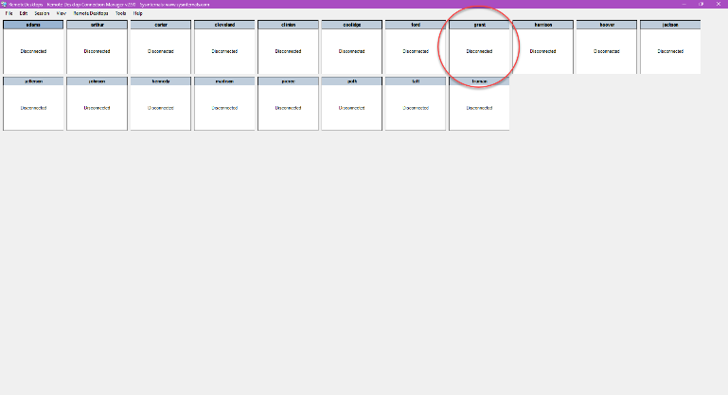  Figure 1: Open a connection to the Grant… | 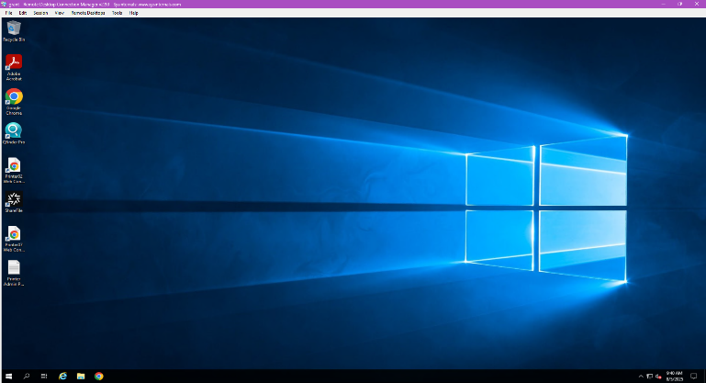  Figure 2: ...and login to the server.
- Open an elevated command prompt and type net stop spool.
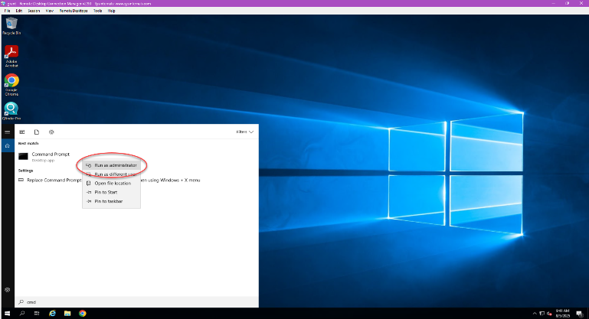  Figure 3: Open an elevated Command Prompt… | 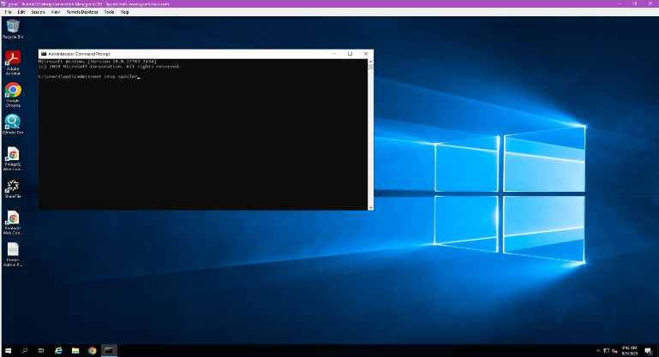  Figure 4: ...and type the command.

Deleting the Files
- Open File Explorer and navigate to C:\Windows\System32\spool\PRINTERS.
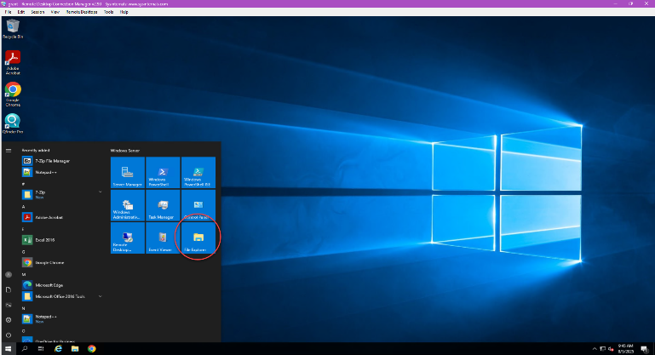  Figure 5: Open File Explorer… | 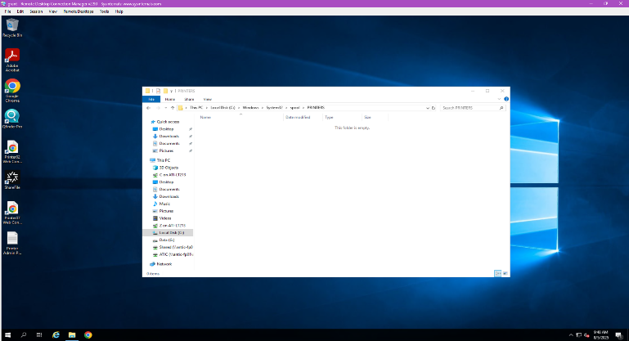  Figure 6: ...and navigate to the folder.
- Select all the files and delete all files in the folder if there are any.
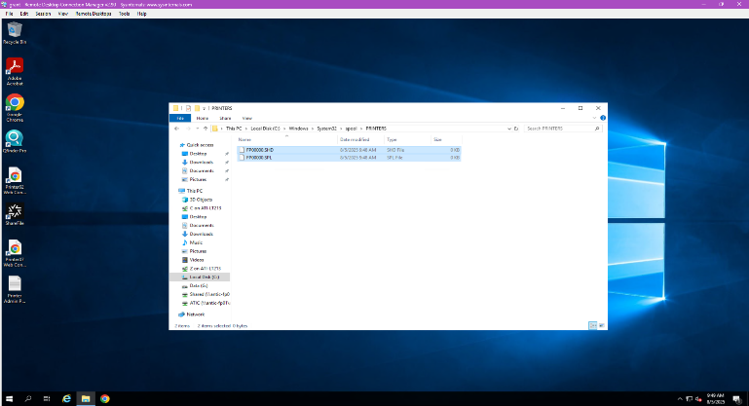  Figure 7: Select the folders by pressing CTRL+A… | 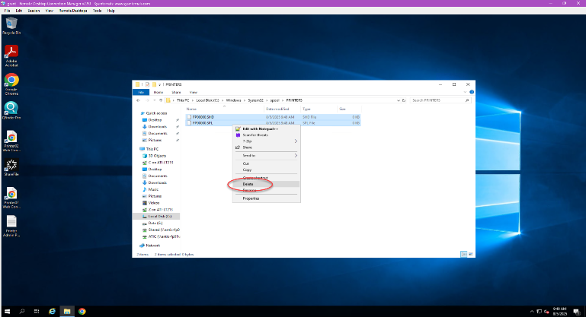  Figure 8: ...and delete them.

Restarting the Spooler
- Open an elevated command prompt and type net start spool.
  Figure 9: Open an elevated Command Prompt… | 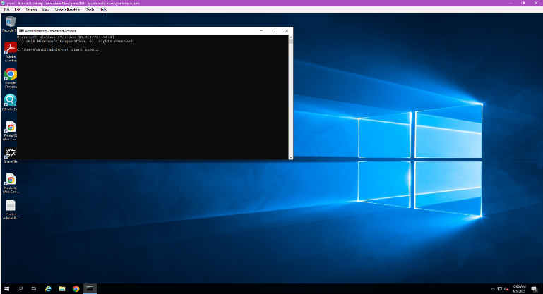  Figure 10: ...and type the command.

